🔐 LAB: Symmetric vs Asymmetric Encryption using OpenSSL
Module 01 – Practical Execution

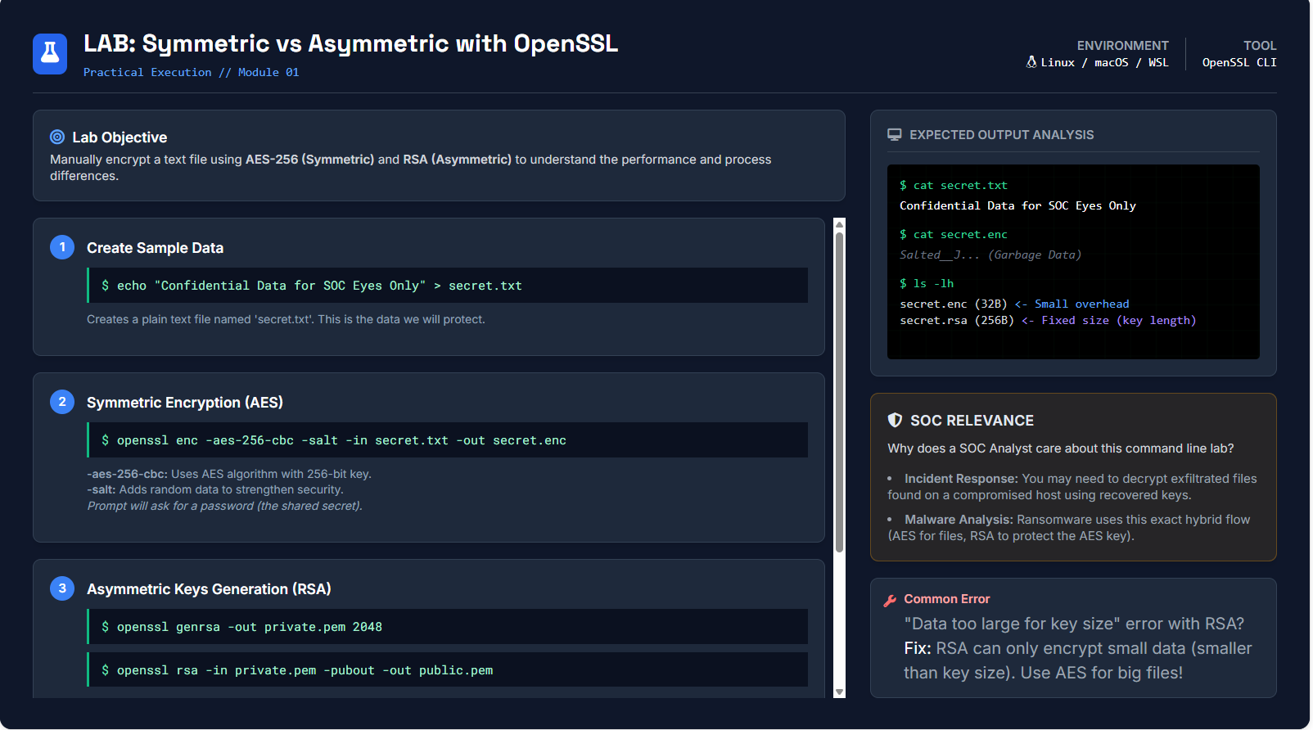

🧭 Big Picture First (Why this lab exists)
This lab is designed to answer one fundamental question:
❓ Why do real systems use BOTH symmetric and asymmetric encryption instead of only one?
You will feel the answer by:
- encrypting the same data in two different ways
- observing size, speed, and limitations
- mapping it to SOC + ransomware + TLS reality

🎯 Lab Objective (Decoded)
Manually encrypt a text file using AES-256 (Symmetric) and RSA (Asymmetric) to understand the performance and process differences.
This means you will learn:
- How encryption actually happens at OS level
- Why RSA is not used for large data
- Why AES is used for files
- Why RSA is used for keys
- Why hybrid encryption exists

🧪 Environment & Tool
- OS: Linux / macOS / WSL
- Tool: OpenSSL CLI
OpenSSL is NOT just a tool — it is the backbone of TLS, HTTPS, certificates, VPNs, and ransomware crypto.

🧩 STEP 1: Create Sample Data

echo "Confidential Data for SOC Eyes Only" > secret.txt
What this does
- Creates a plain-text file
- This represents:
  - credentials
  - logs
  - stolen data
  - sensitive documents
Verify:

cat secret.txt
Output:

Confidential Data for SOC Eyes Only
📌 Security state:
❌ No protection
❌ Readable by anyone
❌ Zero confidentiality

🔐 STEP 2: Symmetric Encryption (AES-256)

openssl enc -aes-256-cbc -salt -in secret.txt -out secret.enc

🔍 Break the command (VERY IMPORTANT)
openssl enc
- Uses OpenSSL’s encryption engine
-aes-256-cbc
- AES = Advanced Encryption Standard
- 256 = Key size (very strong)
- CBC = Cipher Block Chaining (each block depends on previous)
-salt
- Adds random data
- Prevents rainbow table attacks
- Ensures same password ≠ same output
-in secret.txt
- Input plaintext
-out secret.enc
- Output encrypted file

🔑 What happens internally
- You enter a password
- Password → Key (via key derivation)
- AES encrypts data block by block
- Output becomes unreadable binary data

Verify Encryption

cat secret.enc
Output:

Salted__�J... (Garbage Data)
📌 This is expected.

📦 File Size Check

ls -lh
Example:

secret.txt 32B
secret.enc 48B ← small overhead
Key Learning
- AES handles large files efficiently
- Minimal size increase
- Extremely fast
✅ Perfect for files, disks, backups, ransomware

🔑 STEP 3: Asymmetric Key Generation (RSA)
Now we switch to public-key cryptography.

Generate Private Key

openssl genrsa -out private.pem 2048
What this does
- Creates an RSA private key
- Length = 2048 bits (industry minimum)
- This key must be protected at all costs
📌 Private key = power

Generate Public Key

openssl rsa -in private.pem -pubout -out public.pem
What this does
- Extracts the public key
- This key can be:
  - shared
  - embedded
  - published
📌 Public key = lock
📌 Private key = key

🔐 STEP 4: Asymmetric Encryption Attempt (RSA)
If you try to encrypt secret.txt directly using RSA:

openssl rsautl -encrypt -inkey public.pem -pubin -in secret.txt -out secret.rsa
What happens?
❌ You may get:

Data too large for key size

🚨 Why this error happens (CRITICAL CONCEPT)
RSA is NOT designed for large data.
RSA limitations:
- Can encrypt only data smaller than key size
- 2048-bit key ≈ 256 bytes max
- Slow computation
- Fixed output size
📌 RSA is mathematical, not block-based like AES.

📦 RSA File Size Observation

ls -lh
Example:

secret.rsa 256B ← fixed size
Key Learning
- RSA output size depends on key length
- NOT input size
- Extremely inefficient for files

🧠 FINAL CONCLUSION (Core Learning)
Feature | AES (Symmetric) | RSA (Asymmetric)
Speed | Very Fast | Slow
File Size | Efficient | Fixed / Limited
Key Sharing | Hard | Easy
Use Case | Files, disks | Keys, certificates
SOC Reality | Ransomware | TLS, key exchange

🔗 Why Hybrid Encryption Exists
Real systems do this:
- 🔑 Generate random AES key
- 📁 Encrypt file using AES
- 🔐 Encrypt AES key using RSA
- 📦 Send both together
This is called Hybrid Encryption.
📌 Used in:
- HTTPS
- VPNs
- Secure email
- Ransomware

🛡️ SOC RELEVANCE (Why Analysts Must Know This)
🔍 Incident Response
- You may recover:
  - AES keys
  - RSA private keys
- Correct decryption depends on understanding this flow
🦠 Malware Analysis
- Ransomware uses:
  - AES → encrypt files
  - RSA → protect AES key
🔐 Certificate Analysis
- TLS uses RSA/ECC for key exchange
- AES for data transfer

🚫 Common Mistake (Highlighted in Lab)
❌ Trying to encrypt large files directly with RSA
Correct Fix:
✔ Use AES for data
✔ Use RSA to protect AES key

